CALCULATION OF PROCESSING GAIN AND GENERATION OF PN SEQUENCES FOR SPREAD SPECTRUM COMMUNICATION USING MATLAB SIMULATION
Analog and Digital Communication — Experiment 27
Date of Experiment | 12/10/2026
Performed By | Lokesh A
Register Number | 192512293
1. Aim
To calculate the processing gain of a spread-spectrum communication system from the data rate and chip rate, generate a 31-bit pseudo-noise (PN) sequence in MATLAB, and display the sequence graphically.
2. MATLAB Program
clc;
clear;
close all;
% Processing Gain
Rb = 1000; % Data Rate (bps)
Rc = 10000; % Chip Rate (chips/s)
PG = Rc/Rb;
PG_dB = 10*log10(PG);
fprintf('Processing Gain = %.2f\n', PG);
fprintf('Processing Gain (dB) = %.2f dB\n', PG_dB);
% Generate PN Sequence
pn = randi([0 1],1,31); % 31-bit PN sequence
% Display
disp('PN Sequence:');
disp(pn);
% Plot
figure;
stem(pn,'filled');
title('Pseudo Noise (PN) Sequence');
xlabel('Chip Number');
ylabel('Chip Value');
grid on;
3. Output
The MATLAB output calculates a processing gain of 10.00, equivalent to 10.00 dB. It also generates a random 31-bit PN sequence and displays the chip values as a stem plot. The sequence changes between executions because it is generated using randi.
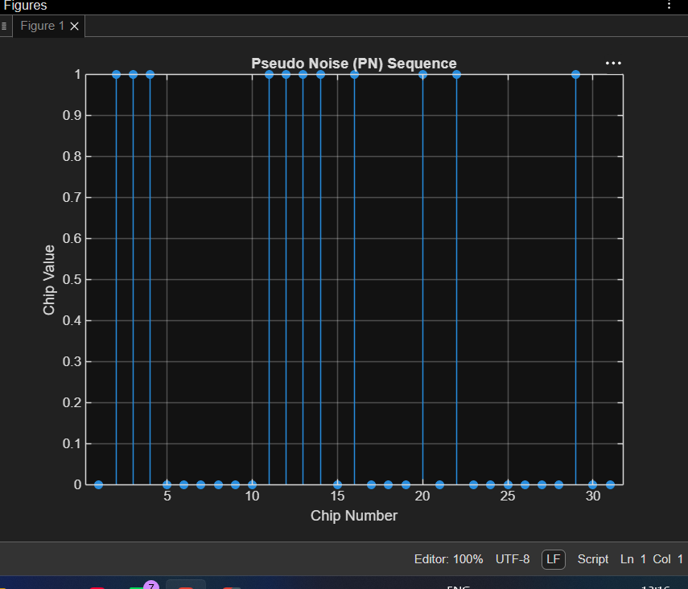
Figure 1: MATLAB command-window output showing the processing gain and generated PN sequence.
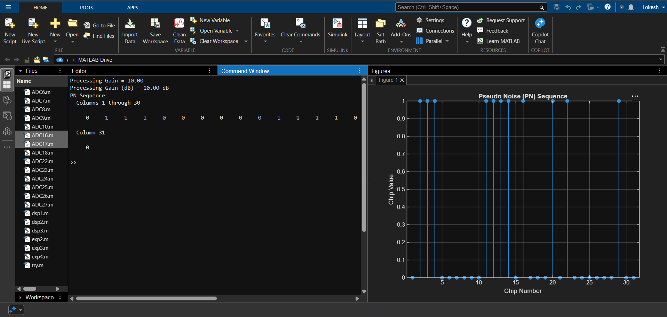
Figure 2: Stem plot of the generated 31-chip pseudo-noise sequence.
4. Simulation Parameters
Parameter | Value
Data rate (Rb) | 1000 bps
Chip rate (Rc) | 10000 chips/s
Processing gain (PG = Rc/Rb) | 10
Processing gain in dB | 10.00 dB
PN sequence length | 31 bits/chips
PN sequence generation | randi([0 1],1,31)
5. Procedure
- Clear the MATLAB workspace and close any open figures.
- Define the data rate and chip rate.
- Calculate the processing gain by dividing the chip rate by the data rate.
- Convert the processing gain to decibels using 10 log10(PG).
- Generate a 31-bit random binary PN sequence.
- Display the generated sequence in the Command Window.
- Plot the PN sequence using a stem plot with chip number and chip value axes.
6. Applications
- Spread-spectrum communication systems.
- Code-division multiple access (CDMA) systems.
- Signal spreading and interference resistance.
- Synchronization and identification of communication signals.
7. Result and Discussion
The processing gain was calculated as Rc/Rb = 10000/1000 = 10, which corresponds to 10 log10(10) = 10 dB. A 31-bit random PN sequence was generated and plotted successfully. The displayed chip sequence is random and may differ each time the program is executed.
8. Conclusion
The MATLAB simulation demonstrated the calculation of processing gain and the generation and graphical representation of a PN sequence for spread-spectrum communication. The calculated processing gain was 10 (10 dB), and the 31-chip sequence was displayed using a stem plot.
DONE BY
Lokesh A
Register Number: 192512293
B.E. Electronics and Communication Engineering (ECE)

